**Assume you are an embedded engineer tasked with designing a smart environmental monitoring system. To ensure the project is well-r ganized and all components are accounted for, prepare a table listing the components, the functions, estimated costs, and the microcontroller (MCU) to be used.**

Designing a smart environmental monitoring system involves creating a robust, reliable, and efficient solution capable of measuring and reporting various environmental parameters such as temperature, humidity, air quality, light intensity, and more. This system requires careful selection of sensors, communication protocols, and power management components, all centered around a suitable microcontroller that can handle the data processing and connectivity needs. The goal is to develop a cost-effective system that can operate autonomously, particularly in remote or off-grid locations, while providing accurate, real-time data for environmental analysis and decision-making.

**1. Components and Their Functions**

The core of any environmental monitoring system is its sensors, each designed to measure specific environmental factors:

* **DHT22 (Temperature & Humidity Sensor)**: The DHT22 is a popular sensor that provides accurate measurements of temperature and humidity. It uses a capacitive humidity sensor and a thermistor to measure the surrounding air, offering a digital output. This sensor is critical for applications where monitoring indoor or outdoor climate is necessary.
* **MQ-135 (Air Quality Sensor)**: This sensor detects a range of gases including CO2, NH3, and Benzene, making it essential for assessing air quality. It outputs an analog signal that corresponds to the concentration of gases in the air. This is particularly useful in urban areas or industrial zones where pollution monitoring is vital.
* **BH1750 (Light Intensity Sensor)**: The BH1750 measures ambient light intensity in lux, which is important for understanding lighting conditions. This could be useful in agriculture, smart homes, or any application where light levels need to be monitored and adjusted accordingly.
* **BMP280 (Barometric Pressure Sensor)**: This sensor measures atmospheric pressure, which can be used to calculate altitude or predict weather changes. The BMP280 is highly accurate and supports both I2C and SPI interfaces, making it versatile for various applications.
* **Soil Moisture Sensor**: This sensor measures the moisture content in soil, a critical parameter for agriculture and gardening. By monitoring soil moisture, irrigation systems can be automated, ensuring that plants receive the optimal amount of water.
* **Ultrasonic Sensor (HC-SR04)**: While primarily used for distance measurement, in this context, the ultrasonic sensor can measure the water level in tanks or reservoirs. This functionality is essential for water resource management in agricultural or industrial applications.
* **OLED Display (128x64)**: This display provides a simple, user-friendly interface for real-time data visualization. It’s particularly useful for local monitoring where immediate feedback is needed without relying on a remote server or app.

**2. Communication Interfaces**

Sensors communicate with the microcontroller using various protocols, each chosen based on the sensor’s design and the needs of the system:

* **Digital (Single-wire)**: Used by the DHT22, this interface is straightforward, requiring just a single data line for communication. It’s easy to implement but is generally used for low-bandwidth data.
* **Analog**: Analog sensors like the MQ-135 and Soil Moisture Sensor output a voltage proportional to the measured parameter. These signals are read by the microcontroller’s analog-to-digital converter (ADC). Analog interfaces are simple but can be susceptible to noise and require careful calibration.
* **I2C**: The I2C protocol is widely used for sensor communication due to its simplicity and ability to support multiple devices on the same bus. Sensors like the BH1750 and BMP280 use I2C, allowing them to share a common interface with the microcontroller, which reduces the number of required pins.
* **SPI**: The BMP280 also supports SPI, which is faster than I2C and is used in applications requiring high-speed data transfer. However, it requires more pins than I2C, so it’s used selectively.

**3. Power Supply Requirements**

Powering the system efficiently is crucial, especially if the monitoring station is deployed in a remote location:

* **LiPo Battery (3.7V, 2000mAh)**: The LiPo battery is chosen for its high energy density, which allows it to power the system for extended periods. It provides a stable 3.7V output, which is ideal for most sensors and the microcontroller.
* **Solar Panel (5V, 1W)**: To make the system sustainable and reduce maintenance, a solar panel can be used to charge the battery. This setup is particularly advantageous for outdoor deployments where direct access to power lines is impractical.
* **Voltage Regulator (AMS1117)**: The voltage regulator steps down the voltage from the battery or solar panel to a consistent 3.3V, which is required by most sensors and the microcontroller. This ensures that the system operates reliably under varying power conditions.

**4. Microcontroller Selection**

The **ESP32** microcontroller is an ideal choice for this system due to its robust features:

* **Built-in Wi-Fi and Bluetooth**: The ESP32 supports both Wi-Fi and Bluetooth, which allows for flexible connectivity options. It can send data to a remote server or directly to a smartphone or tablet. This is critical for real-time monitoring and control.
* **Multiple GPIOs**: The ESP32 has a sufficient number of general-purpose input/output (GPIO) pins to connect all the sensors. It also has analog inputs (ADC) for reading data from sensors like the MQ-135 and Soil Moisture Sensor.
* **Low Power Consumption**: Although it has powerful features, the ESP32 is designed for low power operation, which extends the battery life and makes it suitable for remote monitoring applications.

**5. Cost Estimation**

The estimated cost for each component is calculated based on current market prices, aiming to keep the overall system cost-effective while maintaining high performance:

* **Sensors**: The cost of sensors varies based on their complexity and precision. For instance, the DHT22 and MQ-135 are relatively affordable but provide crucial environmental data.
* **Microcontroller**: The ESP32 is moderately priced but offers a range of features that justify its cost. Its inclusion reduces the need for additional modules or communication devices, which helps in keeping the system compact and cost-efficient.
* **Power Supply Components**: The combination of a LiPo battery, solar panel, and voltage regulator ensures that the system can operate autonomously, which is a key requirement for many environmental monitoring applications. While these components add to the cost, they provide significant value in terms of sustainability and reduced maintenance.

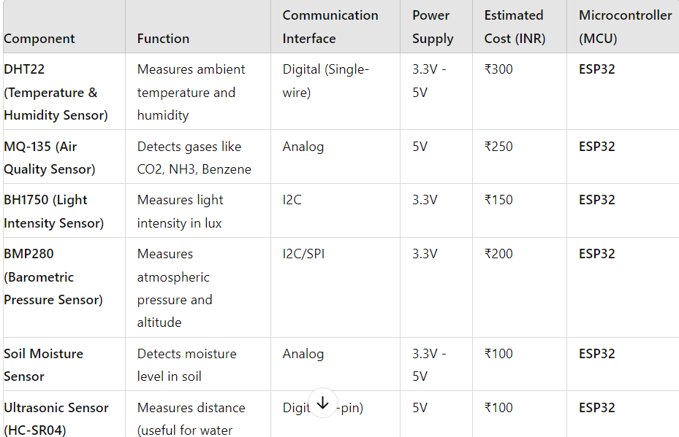

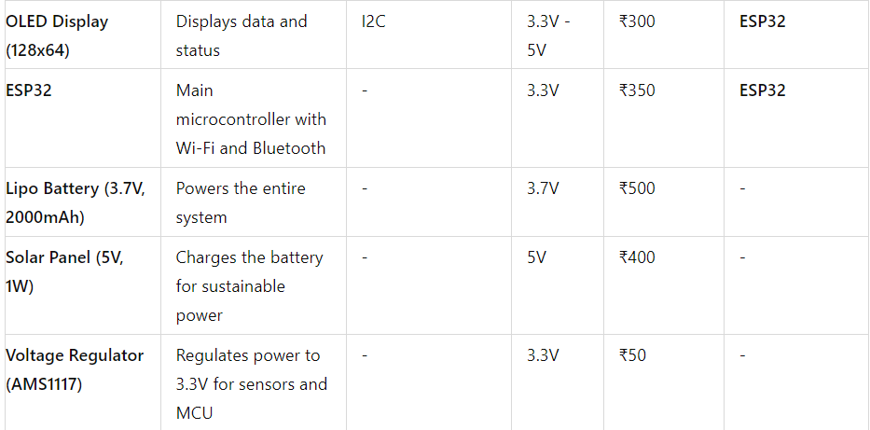

This smart environmental monitoring system is designed to be comprehensive, reliable, and cost-effective. By carefully selecting sensors that cover a wide range of environmental parameters and integrating them with a powerful microcontroller like the ESP32, the system can provide accurate, real-time data for a variety of applications. The inclusion of a sustainable power solution further enhances its suitability for remote deployments, ensuring continuous operation with minimal human intervention. The overall cost is kept within a reasonable range, making it accessible for both personal and industrial use.